WILDERNESS RESOURCE ADVISOR
FINAL REPORT
06/26/2015
MEMO TO: Paul Flanagan, Agency Administrator
FROM: Pat McGervey, Resource Advisor

Incident Date(s): June 6th, 2015 to June 26, 2015
Incident Name: Horse Tank Fire
Incident Number: 2015-AZ-COF-00429
Fire Location (Legal Description): T12N, R9E, Section 22
Incident Commander: Kempton, Dave
Incident put in Patrol Status: June 26, 2015
Point of Origin: 34.49139 N / 111.48778 W
Fire Cause: Natural (lighting)
Size of Fire: 3,603 Acres
Wilderness Acreage: 300 Acres
The Horse Tank Fire began with lighting on Saturday June 6th, 2015. The decision was made to manage the Horse Tank Fire for multiple benefits. In the planning stages approximately 300 acres of the Fossil Springs Wilderness were identified in the planning area.
Hand line was planned for the western parameter connecting two forest roads across Horse Tank Wash. On Tuesday June 9th, 2015 the Scott Russell, Acting Forest Supervisor, authorized the use of mechanized equipment (chainsaws) for approximately 20 chains (~1300 feet) across this short section of the wilderness (authorization letter attached).
On June 11th the handline was constructed through the wilderness and subsequently brunt out on the north side of Horse Tank Wash. The south side of the handline was constructed but not burnt and maybe used if needed.
On June 23rd, Pat McGervey, inspected the handline in the Fossil Springs Wilderness as well as evaluated the fire impacts to the wilderness character. This section of the wilderness is very remote, inaccessible, and shows little signs of human presence.
The character of the land where the handline was constructed consisted of extremely steep slopes, with light fuels mostly consisting of brush and rock. The Blue Ridge Hotshots did an excellent job of constructing the line using Minimum Impact Suppression Tactics (MIST) including using many natural barriers like rocks and cliffs instead of constructing line. The line also utilized the minimal width and scrape necessary to hold the fire. Also minimal brush was removed and trees were lightly limbed where necessary instead of felled.
From what could be observed the fire severity was relatively low in the wilderness. A few trees can be seen as scorched and a few torched, but most seem to be intact, indicating a low severity understory burn.
Rehabilitation Recommendations
With the minimal impact on the wilderness from the Horse Tank Fire there are minimal rehabilitation recommendations. Firefighters and crews should walk the handline and pull all flagging. After removing the flagging it is recommended that the intersection of the handline and Forest System Road 9361Q be covered with slash. There are adequate juniper boughs in this location, the line could be slashed out of site about 75 feet. No water bars or further rehabilitation is recommended on this part of the fire.
Photos
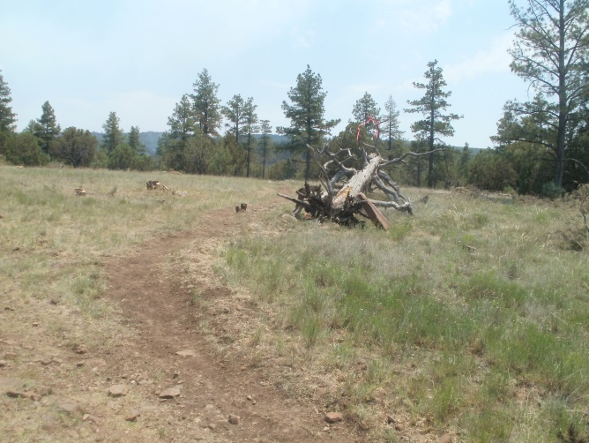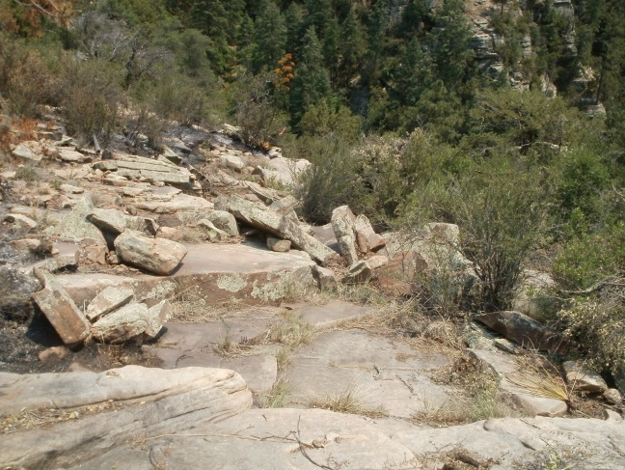
Handline; as it leaves FSR 9361Q towards the Wilderness Typical handline, using natural rock barriers
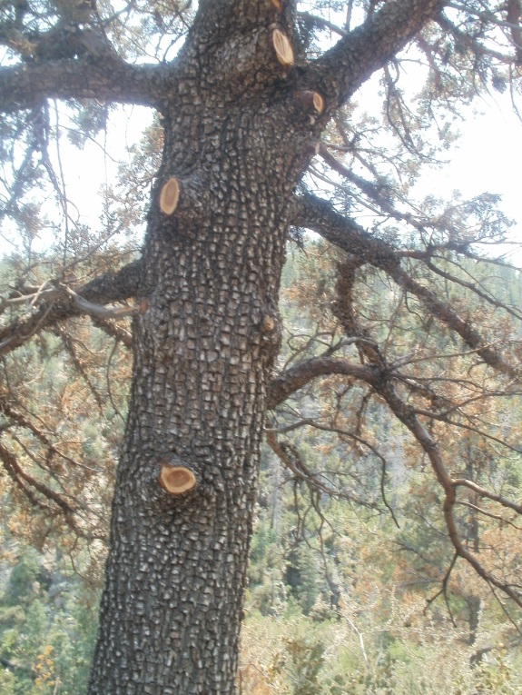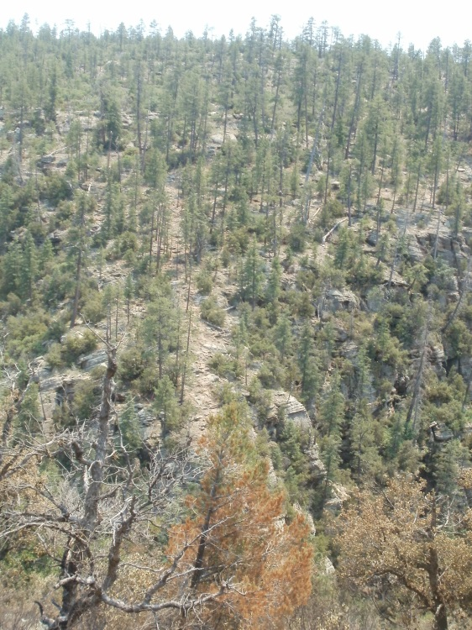
Some limbing with chainsaws is visible Handline is barely visible on the south side of Horse Tank Wash

